Name : Sundaramoorthy S
Reg No : 192324228
Course code : Cloud Computing And Big Data Analysis
Exp No : EXPERIMENT 2
Date : 18/12/2025

EXPERIMENT 2
Title
Creation of a Simple Cloud Software Application for Flight Reservation System to Demonstrate SaaS

Aim
To design, develop, and deploy a cloud-based Flight Reservation System and provide it as a service using a Cloud Service Provider to demonstrate the Software as a Service (SaaS) model.

Procedure
- Select a cloud service provider such as AWS / Azure / Google Cloud / Zoho Creator.
- Create a simple web-based Flight Reservation application.
- Design forms for flight details, user details, and booking information.
- Create a cloud database to store flight schedules, customer details, and booking status.
- Deploy the application on the cloud platform.
- Allow users to access the application through a web browser.
- Store and retrieve booking data from the cloud database.

Sample Dataset
Flights Table
- Flight ID : F101, Airline : Indigo, Source : Chennai, Destination : Delhi, Price : 5500
- Flight ID : F102, Airline : Air India, Source : Chennai, Destination : Mumbai, Price : 6200
Users Table
- User ID : U001, Name : Rahul, Email : rahul@gmail.com
- User ID : U002, Name : Priya, Email : priya@gmail.com
Bookings Table
- Booking ID : B001, User ID : U001, Flight ID : F101, Status : Confirmed

Output
- Flight reservation form displayed on the cloud platform.
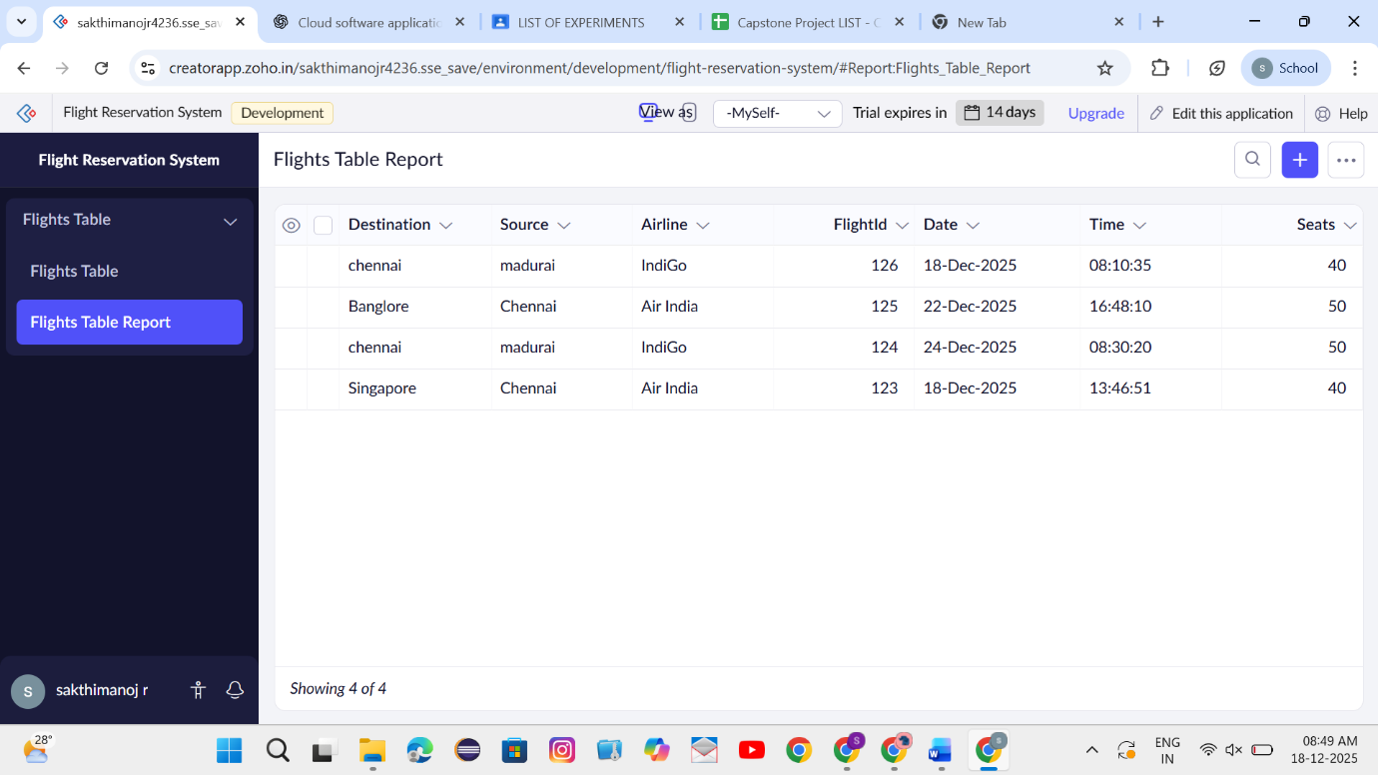

- Users can search flights and submit booking details.
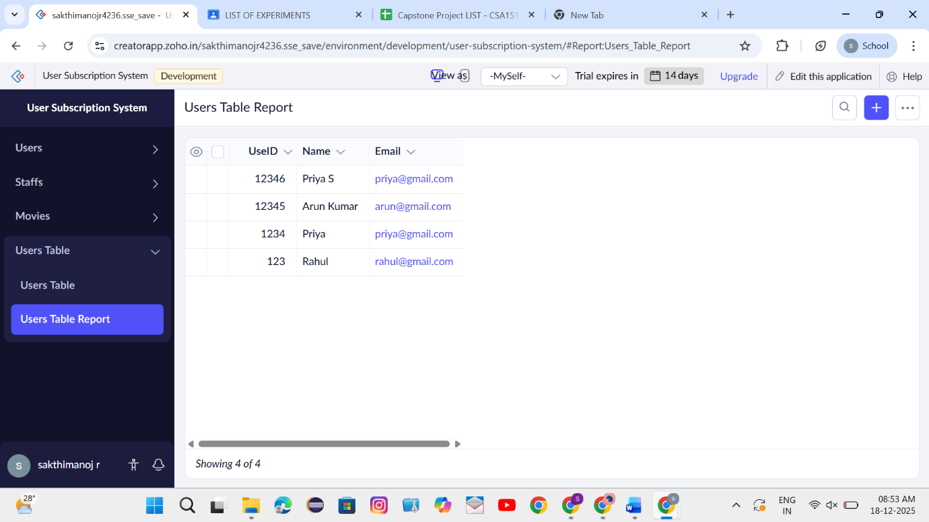

- Booking data is stored and retrieved from the cloud database.
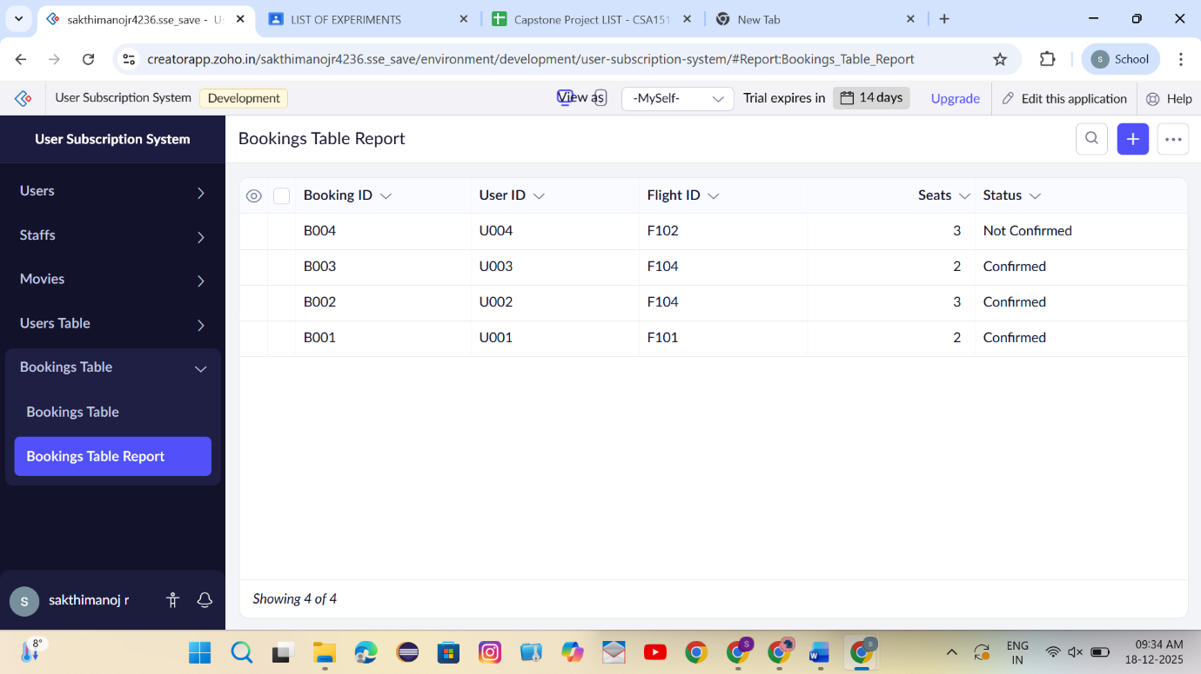

Result
Thus, a simple cloud-based Flight Reservation System was successfully created and deployed using a cloud service provider, demonstrating the Software as a Service (SaaS) model.

